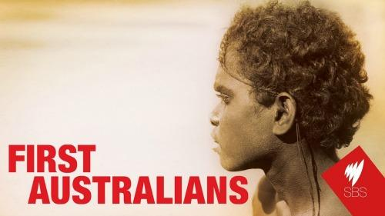
Episode Seven
We Are No Longer Shadows

The video series, First Australians is available on YouTube. This worksheet accompanies
Episode 7: We Are No Longer Shadows.

- List some of the simple things that the civil rights movement fought for in the 1960s

- .........................................................................................................
- .........................................................................................................
- .........................................................................................................
- .........................................................................................................
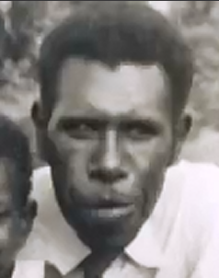
- .........................................................................................................
Eddie Koiki’s background
- What experience of racism did Eddie Koiki Mabo have in 1964 when he had to take his child to hospital in Hughenden in 1964?
................................................................................................................................................................................................................
- Why was belief in the god Marlo central to the lives of people of Murray Island?

................................................................................................................................................................................................................
- What was Mabo’s punishment for drinking and being with a girl?
......................................................................................................................................................................................................................................................................................................................................................
- What were Aboriginal people labelled if they refused to work for less wages than non-Aboriginals? Did Mabo accept this?
.....................................................................................................................................................................................................................................................................................................................................................
- How did Mabo learn that his land on Murray Island was actually Crown Land and not legally owned by him?

.....................................................................................................................................................................................................................................................................................................................................................
- What was the outcome of the opposition by Yolaru people of the Northern Territory against mining companies building mines on their land in the 1970s?

......................................................................................................................................................................................................................................................................................................................................................
- What did Mabo believe about land ownership?

............................................................................................................................................................................
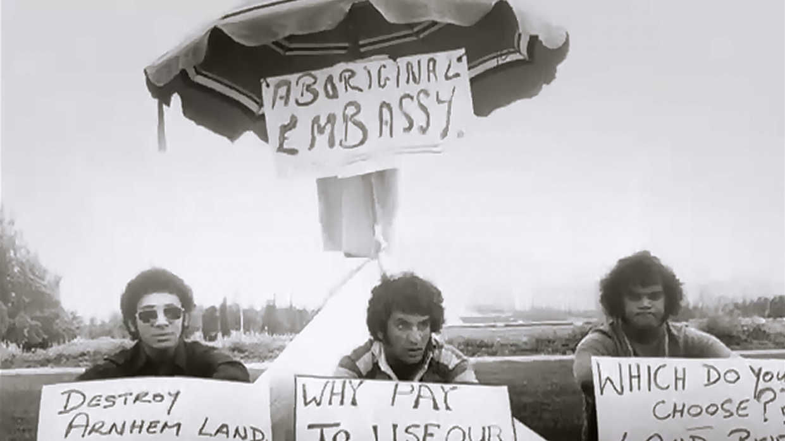
The Tent Embassy
- Why was a Tent Embassy set up in Canberra in 1972?
................................................................................................................................................................................................
- Why did the Tent Embassy come to an end?
...............................................................................................
Mabo’s early works
- Why did Mabo establish a black community school?
...........................................................................................................................................................................
- What are some of the problems faced by Aboriginal people in Queensland in the 1970s?

- ..............................................................................................................
- ..............................................................................................................
- ..............................................................................................................

- How was Mabo treated when he spoke out about injustice?
........................................................................................................................................................................
Mabo’s fights for Land Rights
- What happened at the 1981 Townsville Land Rights Conference?
........................................................................................................................................................................
- What did Mabo do on 20th May, 1982?
........................................................................................................................................................................
- What did Aboriginal people do at the 1982 Commonwealth Games in Brisbane?
........................................................................................................................................................................
17. When did the case of Mabo v. Queensland commence?
.........................................................
- What did the defendants (Queensland) do to attempt to end the Mabo v. Queensland case when it looked like Mabo may win?

................................................................................................................................................................................................................................................................................................................................................
- How did Mabo get the new Queensland law declared invalid?

.........................................................................................................................................................................
..........................................................................................................................................................................

- Why did many Aboriginal people from across the nation travel to Sydney in 1988?
..........................................................................................................................................................................
- Why did the Supreme Court fly to Murray Island? What did they do there?
……………………………………………………………………………………………………….........................................................................................................................................................................................................................................
- What was the 1990 verdict in the Mabo v. Queensland case?
………………………………………………………...........................................................................................................................................................................................................................................................................................
- What happened 5 months after Eddie Koiki Mabo died? Why was this significant?

....................................................................................................................................................................................................................................................................................................................................................
- What was the reaction to the Mabo verdict by non-Aboriginal society?

……………………………………………………………………………………………………………………………………………………………………...........................................................................................................................................................................

--- ANSWERS ---
- List some of the simple things that the civil rights movement fought for in the 1960s

- To swim in a pool
- To try on a dress
- To give birth in a hospital
- To be served in cafes
- To enter hotels
Eddie Koiki’s background
- What experience of racism did Eddie Koiki Mabo have in 1964 when he had to take his child to hospital in Hughenden in 1964?
He had no transport, was refused accommodation for himself and his sick kids because he was black
- Why was belief in the god Marlo central to the lives of people of Murray Island?

Taught everyone respect, not to steal, ownership etc.
- What was Mabo’s punishment for drinking and being with a girl?
Exiled from Murray (Mer) Island. He worked on the diving luggers (diving for pearls) then went to the sugarcane fields to cut cane. It was hard manual labour and he was paid low wages.
- What were Aboriginal people labelled if they refused to work for less wages than non-Aboriginals? Did Mabo accept this?
Communists, anti-Christian
- How did Mabo learn that his land on Murray Island was actually Crown Land and not legally owned by him?

He was working as a gardener at James Cook University and a history lecturer told him. He was shocked.
- What was the outcome of the opposition by Yolaru people of the Northern Territory against mining companies building mines on their land in the 1970s?

They took the matter to court claiming they owned the land. Judge Blackburn said there was strong evidence that they owned the land but they lost on a technicality: Australia does not recognise Aboriginal laws inc. land ownership because the British took over teh land and declared it Terra Nullius – land owned by no-one.
- What did Mabo believe about land ownership?

That ownership of land is unchangeable despite the British assuming control. So Aboriginal people still own their land.

The Tent Embassy
- Why was a Tent Embassy set up in Canberra in 1972?
As a protest against Aboriginal people not being given rights to their own land. The tent was a symbol of dispossession.
- Why did the Tent Embassy come to an end?
6 months after it was set up the police dismantled it.
Mabo’s early works
- Why did Mabo establish a black community school?
He didn’t want black children to lose their culture
- What are some of the problems faced by Aboriginal people in Queensland in the 1970s?

- Poor housing
- Sub-standard health
- No legal representation

- How was Mabo treated when he spoke out about injustice?
He got death threats. He slept in the loungeroom with a gun.
Mabo’s fights for Land Rights
- What happened at the 1981 Townsville Land Rights Conference?
Mabo organised the conference and is given instructions on how to organise a legal case.
- What did Mabo do on 20th May, 1982?
He made a statement of claim over Murray Island and its surrounding waters. It is supported by Legal Aid and barrister Bryan Keon-Cohen.
- What did Aboriginal people do at the 1982 Commonwealth Games in Brisbane?
Organised a demonstration which was reported on the front page of newspapers around the world. It embarrassed the
17. When did the case of Mabo v. Queensland commence?
1986
- What did the defendants (Queensland) do to attempt to end the Mabo v. Queensland case when it looked like Mabo may win?

The State of Queensland passed a new law which stated that as of 1879 when Queensland took over the Torres Strait Islands all property passed to the ownership of Queensland, extinguishing ownership by native peoples.

- How did Mabo get the new Queensland law declared invalid?

He took it to the High Court and claimed that the new law was an act of racial discrimination. The High Court agreed and declared the law invalid. Mabo’s case against Queensland could continue.

- Why did many Aboriginal people from across the nation travel to Sydney in 1988?
The Bicentennary was being celebrated in Sydney. They were expecting Prime Minister Hawke to fulfil his promise to grant native title. But they were disappointed because nothing happened.
- Why did the Supreme Court fly to Murray Island? What did they do there?
To view Mabo’s claims that the native people recognised personal ownership of land.
- What was the 1990 verdict in the Mabo v. Queensland case?
Judge Moinahan delivered the verdict. He did not believe that Mabo was heir to his father’s land because Eddie Koiki Mabo was adopted as a child and the adoption was not legal under Queensland law. He said that Eddie Mabo therefore did not own the land
- What happened 5 months after Eddie Koiki Mabo died? Why was this significant?

The High Court made its decision about Mabo’s claim to native title. It decided that the first Australians were owners of the land prior to European occupation.

- What was the reaction to the Mabo verdict by non-Aboriginal society?

State governments, mining companies and landowners – all dominated by non-Aboriginals commence a public campaign to discredit native title. They claimed that it would result in social anarchy and destroy the economy.

